Patient Information:
PATIENT INFORMATION

Last Name: _ First Name: MI: _
Address: _

City:
State: Zip:

SS # Birthdate:
Sex: ◻F ◻M

Home Phone # Work Phone #
Cell Phone # (opt.): E-mail (opt.):
Doctor: Dr. Phone #
Who may we thank for referring you?
Relationship:
In case of emergency, please contact:
Relationship to patient: Phone #

Responsible party information, if different from patient:
(This office offers the courtesy of Insurance Billing. However, we do not have a contract with all companies.)

Last Name: _ First Name: MI:
Address: City: _ State: Zip:
Employer: _ Employer name:

I understand, as the patient and/or above mentioned responsible party, that I am fully responsible for payment of all charges incurred. I understand that, where appropriate, credit bureau reports may be obtained.

I authorize my insurance benefits to be paid directly to Little Bird Therapies for services rendered. I understand I am financially responsible for any deductibles, non-covered services, or non-authorized services. I authorize Little Bird Therapies to release any information requested by the insurance company with regards to payment of benefits.

Signature
Date _

MEDICAL HISTORY

1. Please list any significant past injuries or surgeries relevant to the condition for which you seek Therapy:

Type _
Year
Type _
Year
Type _
Year
Type _
Year
Type _
Year

2. Have you had any tests for your current symptoms? ◻Yes ◻No

If yes, please check: ◻X-ray ◻Bone Scan ◻CAT Scan ◻MRI ◻Nerve Conduction Test
Other: Results:

3. Do you currently have or have you had a history of the following:

◻ AIDS
◻ Allergies
◻ Anemia
◻ Arthritis
◻ Artificial Heart Valves

◻ Artificial Joints
◻ Asthma
◻ Cancer Treatment
◻ Cardiac Pacemaker
◻ Diabetes

◻ Heart Murmur
◻ Heart Trouble
◻ High Blood Pressure
◻ Psychiatric Treatment
◻ Stroke

4. Are you currently taking medication for this or any other medical problem? ◻Yes ◻No
If yes, please list:

SUBJECTIVE EVALUATION

1. What is your primary complaint? _

2. Describe how and when your symptoms began:

3. Mark on the scale your ◻ ◻ ◻ ◻ ◻ ◻ ◻ ◻ ◻ ◻ ◻   0 = No pain at all
current level of discomfort: 0 1 2 3 4 5 6 7 8 9 10 10 = Worst pain imaginable

4. What aggravates your symptoms?:

5. What eases your symptoms?:

6. If appropriate, comment on the following:
How do symptoms change in the morning? Throughout the day? _ In the evening?

7. Overall how have your symptoms progressed? ◻Getting better ◻Unchanged ◻Getting worse
Explain how:

8. Have you had treatment for your current symptoms? ◻ Y ◻ N
If yes, describe treatment and results:

On the body chart below, please mark you symptom areas:
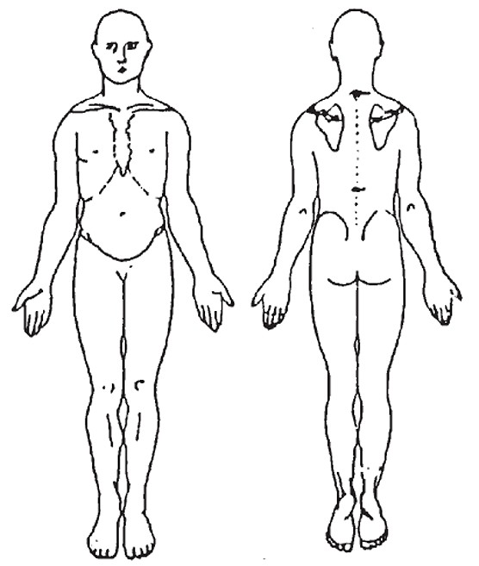
10. What is your work/hobby?
Work: Hobby:

11. Are you currently working? ◻ Yes ◻No
If no, is it because of your symptoms? ◻Yes ◻No

12. Describe the physical demands of your work:
◻Heavy ◻Moderate ◻Light ◻Sedentary
Specifics:

13. Describe the physical demands of your recreational
activities or hobbies:

14. Are you able to participate in your recreational activities or hobbies: ◻ Yes ◻No
If no, explain:

15. Are you having difficulty performing your daily activities? ◻ Yes ◻No
If yes, explain:

16. What do you think is the cause of your symptoms?

17. What are your goals for Therapy?

    

By signing below, I attest that the above information is true and complete to the best of my knowledge.

Signature of Patient / Guardian:
Date: _

For the treatment of minors, I hereby grant permission for Therapy to be performed on this minor.

Parent Signature:
Date:

Signature:
Date

